Unit 4 AP Progress Check (College board Questions)
- Which of the following is true for both stocks and bonds?
- They are interest bearing assets.
- They are easily converted to cash.
- They are risk free assets.
- They are equity.
- They are the most liquid form of financial assets.

- Cash, a house, bonds and a savings account are all financial assets. Which of the following rankings lists these assets from the least liquid to the most liquid?
- Cash, bonds, house, savings account
- Bonds, house, savings account, cash
- Savings account, cash, bonds, house
- House, bonds, savings account, cash
- Cash, savings account, bonds, house

- Nathan has been unable to trust banks since the failure of his savings and loan bank. He claims that storing his hard-earned money at home is costless. Is Nathan correct?
- Yes, because money is the most liquid form of financial assets.
- Yes, because there is no opportunity cost in holding money.
- Yes, because the opportunity cost of holding money is the real value of goods and services it can purchase.
- No, because money is the least liquid form of financial assets.
- No, because the opportunity cost of holding money is the lost interest he could have earned on other financial assets.

- Which of the following is adjusted by the actual inflation rate?
- Nominal wages
- Automatic stabilizers
- Unemployment rate
- Price of previously issued bonds
- Real interest rates

- Spencer took a 9 percent one-year fixed rate loan to buy a new car. He expected to pay a real interest rate of 5 percent. If at the end of the year Specner only paid a 3 percent real interest rate, which of the following is true?
- The nominal interest rate was 3%
- The nominal interest rate was 5%
- The actual inflation rate was 2%
- The actual inflation rate was 4%
- The actual inflation rate was 6%

- If the interest rate on a one-year loan is 5% and the expected inflation rate is -2% for the same period, what is the expeted real interest rate on the loan?
- -7%
- -2%
- 2%
- 3%
- 7%

- Which of the following transactions will keep M1 unchanged?
- Sam transferred money from his certificate of deposit to his checking account.
- Mike purchased government bonds and paid with a check.
- Leila deposited coins from her piggy bank into her checking account.
- Sandy took money out of her retirement fund and converted to cash.
- Patty increased her monthly cash deposits to her retirement funds.

- Which of the following is included in the monetary base?
- Currency held by the public and commercial bank reserves held with the central bank
- currency held by the public, demand deposits at depository institutions and commercial bank reserves held with the central bank
- Currency held by the public, demand deposits, savings deposits and certificates of deposit
- Currency held by the public and small and large time deposits
- Currency held by the public, small and large time deposits and commercial bank reserves held with the central bank

- Mia transferred $1,000 from her checking account to a certificate of deposit. How will M1 and M2 measures of the money supply change?
- M1 will increase and M2 will decrease.
- M1 will increase and M2 will increase.
- M1 will decrease and M2 will increase.
- M1 will decrease and M2 will not change.
- M1 will not change and M2 will increase.

- Northern City Bank keeps no excess reserves. Assume Northern City Bank receives a deposit of $50 million dollars. As a result of the deposit, Northern City Bank’s required reserves increase by $10 million. What is the maximum possible change in the money supply in the banking system that could result from the $50 million deposit?
- The money supply will increase by a maximum of $10 million.
- The money supply will increase by a maximum of $40 million.
- The money supply will increase by a maximum of $50 million.
- The money supply will increase by a maximum of $200 million.
- The money supply will increase by a maximum of $250 million.

- Southern City Bank has $100 million in deposits and has $8 million in excess reserves. If the required reserve ratio is 5%, which of the following is true?
- The money multiplier is 20, and the bank can lend out up to $160 million.
- The money multiplier is 8, and the bank can lend out up to $20 million.
- The money multiplier is 8, and the bank can lend out up to $5 million.
- The money multiplier is 8, and loans can increase in the banking system by a maximum of $8 million.
- The money multiplier is 20, and loans can increase in the banking system by a maximum of $160 million.

- Which of the following explains why the amount predicted by the value of the simple money multiplier may be overstated?
- It does not take into account the amount of bank loans.
- It does not take into account the marginal propensity to consume.
- It does not take into account a bank’s desire to hold excess reserves.
- It does not take into account changes in expected inflation.
- It does not take into account changes in savings.

- Which of the following describes the relationship between the nominal interest rate and the quantity of money people want to hold as depicted by the money demand curve?
- Positive, and the money demand curve is upward sloping.
- Positive, and the money demand curve is downward sloping.
- Positive, and the money demand curve is vertical.
- Inverse, and the money demand curve is upward sloping.
- Inverse, and the money demand curve is downward sloping.

- Use the graph to answer the following question.
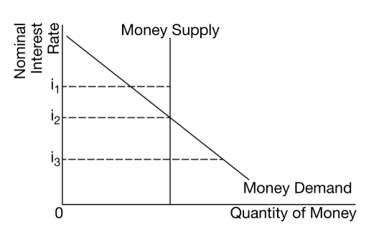
Which of the following is true at the nominal interest rate (i3) ?
- The money market is at equilibrium because the quantity demanded is equal to the quantity supplied.
- There is a surplus in the money market because the quantity demanded is less than the quantity supplied.
- There is a surplus in the money market because the quantity demanded is greater than the quantity supplied.
- There is a shortage in the money market because the quantity demanded is greater than the quantity supplied.
- There is a shortage in the money market because the quantity demanded is less than the quantity supplied.

- An increase in the price level will affect the money market and bond market in which of the following ways?
- The nominal interest rate rises, and the price of previously issued bonds rises.
- The nominal interest rate falls, and the price of previously issued bonds is unaffected.
- The nominal interest rate rises, and the price of previously issued bonds falls.
- The nominal interest rate falls, and the price of previously issued bonds rises.
- The nominal interest rate is unaffected, and the price of previously issued bonds rises.

- Suppose that the economy has entered a recession. Which of the following is a monetary policy action a central bank can take to restore full-employment output?
- Selling government bonds
- Decreasing government spending
- Decreasing administered interest rates
- Increasing the policy rate
- Increasing the required reserve ratio

- Country X’s economic situation is depicted by the graph above. Which of the following will happen if Country X’s central bank conducts a contractionary monetary policy?
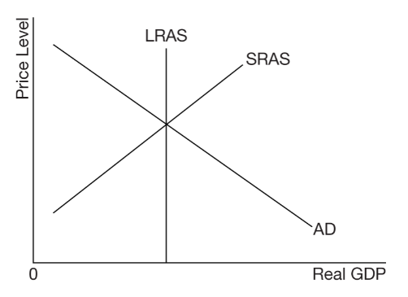
- The economy will be in a recessionary gap; the price level will decrease, and the real output level will increase.
- The economy will be in a recessionary gap; the price level and the real output level will decrease.
- The economy will be at full employment; the price level and the real output level will increase.
- The economy will be in an inflationary gap; the price level and the real output level will increase.
- The economy will be in an inflationary gap; the price level will increase, and the real output level will decrease.

- A country’s central bank purchased government bonds from the public in the open market. How would this action affect the nominal interest rate and the price level in the short run?
- There would be a decrease in the nominal interest rate and a decrease in the price level.
- There would be a decrease in the nominal interest rate and an increase in the price level.
- There would be an increase in the nominal interest rate and a decrease in the price level.
- There would be an increase in the nominal interest rate and a decrease in the price level.
- There would be an increase in the nominal interest rate and no change in the price level.
- Assume the banking system in Zenobia has ample reserves. Which of the following reserve market graphs demonstrates the effect of the central bank of Zenobia increasing its administered interest rates?
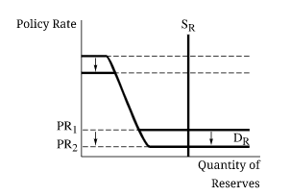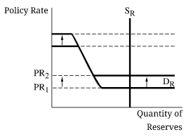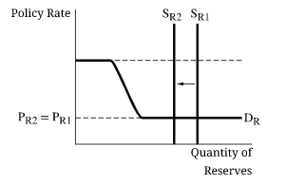
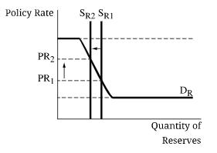
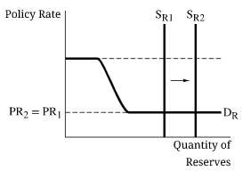

- Which of the following is true about the loanable funds market?
- The demand for loanable funds shows a positive relationship between real interest rates and the quantity demanded of loanable funds.
- The supply of loanable funds shows an inverse relationship between real interest rates and the quantity supplied of loanable funds.
- Investment is financed by national savings in a closed economy.
- Investment is financed by government borrowing in an open economy.
- Public savings is the sum of national savings and private savings.

- The loanable funds market is currently in equilibrium at a real interest rate of r1 . An increase in household savings will affect the loanable funds market in which of the following ways? 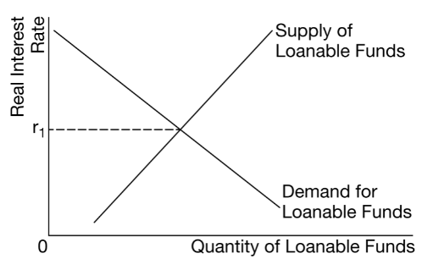
- There will be a surplus of funds and the real interest rate will increase.
- There will be a shortage of funds and the real interest rate will decrease.
- The demand for loanable funds will increase and the real interest rate will increase.
- The supply of loanable funds will increase and the real interest rate will increase.
- The supply of loanable funds will increase and the real interest rate will decrease.

- Country X’s economy is enjoying political stability and attracting foreign financial capital. At the same time Country X’s government is borrowing to finance spending. How will these changes affect the loanable funds market in Country X?
- There will be a decrease in the supply of loanable funds.
- There will be a decrease in the demand for loanable funds.
- There will be an increase in the equilibrium nominal interest rate.
- There will be an indeterminate effect on the equilibrium real interest rate.
- There will be an indeterminate effect on the equilibrium quantity of loanable funds.

1 | B | 11 | E | 21 | E
2 | D | 12 | C | 22 | D
3 | E | 13 | E
4 | E | 14 | D
5 | E | 15 | C
6 | E | 16 | C
7 | C | 17 | B
8 | A | 18 | B
9 | D | 19 | B
10 | D | 20 | C

